**SPI 1.3 Explain the basic functions of a major organ system  
Know: the 11 organ systems and their functions Label each organ system and explain its function.**

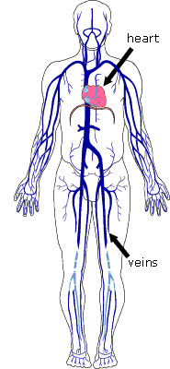

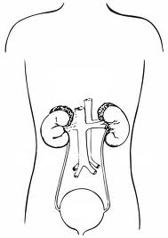

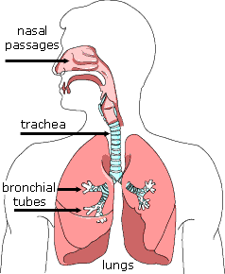

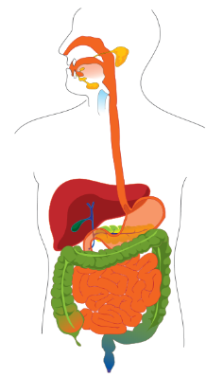

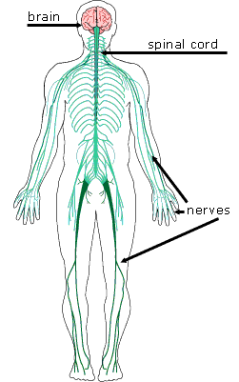

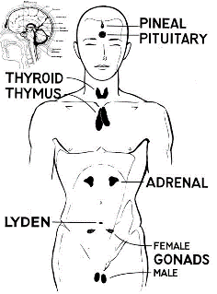

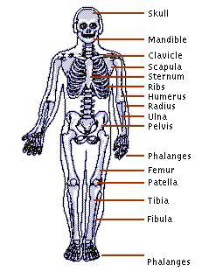

[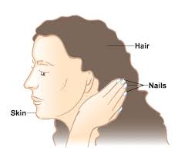](http://www.google.com/imgres?q=skin+nails+and+hair&hl=en&biw=1366&bih=643&tbm=isch&tbnid=9Pc7TogIJGdi1M:&imgrefurl=http://www.nlm.nih.gov/medlineplus/skinhairandnails.html&docid=NH6sdfpt_VOeNM&imgurl=http://www.nlm.nih.gov/medlineplus/images/skinhairandnails.png&w=380&h=360&ei=1v4xUqTmPIu-9QTxp4DgBg&zoom=1&ved=1t:3588,r:36,s:0,i:195&iact=rc&page=2&tbnh=176&tbnw=185&start=25&ndsp=33&tx=113&ty=52)

